NDIS Provider No. 15939044

ACN 001 578 301
ABN 69 001 578 301
Registered Charity No. 12131

Valley Skills for Life Taree & Forster
Valley Supported Living
Valley Transition to Work &
Training
Nature’s Care Nursery
Valley Grounds Care
Valley Timber
Valley Bees
Valley Secure Documents
Valley Linen Service
Valley Café
Valley Vintage
Intalink Therapy Solutions

Ph 02 6552 8888

PO Box 635
Taree NSW 2430

admin@valley-industries.com.au
www.valley-industries.com.au

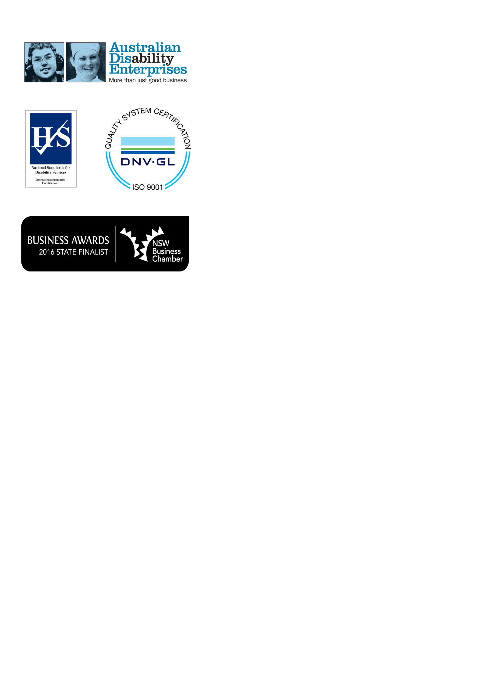

Laundry Assistant

Valley Industries has an opportunity for a passionate and dynamic individual to work part-time in the role of Laundry Assistant at our Valley Linen based in Taree.

This role will requires the successful applicant to be responsible for duties including operating industrial machines to wash, dry and iron clothes and linens including driver delivery and stock control. The ideal applicant will be energetic, efficient and enjoy working in a team.

Selection Criteria

Essential
- Is organised and can effectively manage responsibilities and own priorities and assist others.
- Ability to work in a team environment and with minimal supervision.
- Presents professionally, as appropriate for the occasion.
- Satisfactory National Police Check and Working with Children Check.
Desirable
- Certificate III or IV Laundry Operations
- Current LR NSW Driver’s licence

When you work with Valley Industries you know it’s more than a job. It’s a rewarding career that makes a difference to people’s lives. Come be part of the team at Valley Industries.

To apply for the position please provide your resume and covering letter of at least one A4 page explaining why you are suitable to renee.gilbert@valley-industries.com.au.

Applications close 28th September 2018

